Christmas made easy
(and economic).

Get ahead and make your home-cooked Christmas lunch a breeze that won’t distract you from the rest of the fun. And, if Thanksgiving is your important turkey celebration, these recipes will work for you too.
For the main performance, here is a countdown to your culinary D-Day based on recipes that use a fresh 5.5kg (12lb) turkey (but a chicken would work just as well). The turkey should stretch to the celebratory spread and about 40 more different, delicious meals.
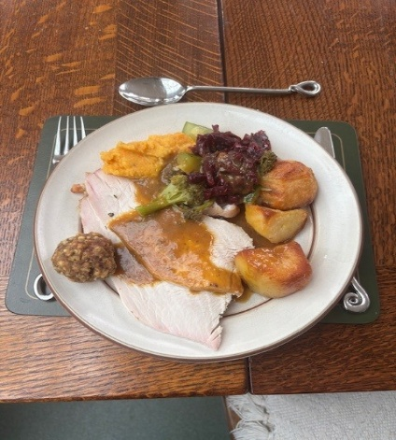

Christmas (or Thanksgiving) lunch Menu.
Roast turkey or chicken and stuffing balls page 6
Gravy page 4
Roast potatoes and parsnips page 6
Root mash page 3
Braised red cabbage page 3
Steamed sprouts, carrots and more page 7
Christmas pudding page 7
Baked Christmas fruit salad page 5

Choosing your bird.
Days defrosting and then roasting a whole big turkey is fine if you want a dramatic entrance, have a skilled carver who can serve the meat quickly enough that everything else doesn’t go cold, and you’ve got lots of people happy to eat left-overs.
For those of us who want an easier life, choosing a fresh turkey that can be cut up beforehand means lots of other meals for the future. Top Tip: find a wonderful butcher like mine to produce:
- 1 breast lobe. To roast and serve 6-8 very generously on the Big Day. To feed more, just use the second lobe too. You can try out the recipe ahead with a whole chicken.
2 wing tips, Giblets and any other carcass bits. For stock, gravy and leek and potato soup
Second breast lobe. Freeze to make lots of turkey curry or Forestier
2 wings and 2 drumsticks. Freeze to make turkey stroganoff
2 thighs. Freeze to make Mediterranean turkey lunches
My important tips for roasting the meat:
- Brining beforehand for 24 hours.
- Slow cooking in a very low oven.
- Using a probe thermometer to check that the internal temperature of the meat (not bone) has reached at least 70C.
- A long resting time before carving.

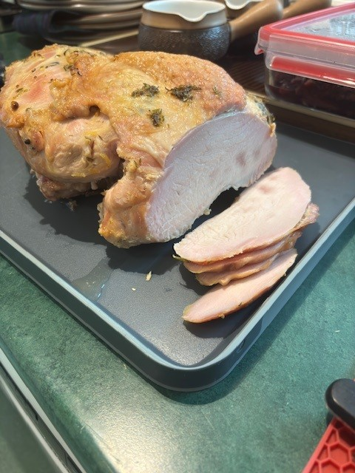

Stuffing/sausages.
Rather than having extra work and complication on the day, balls of my butcher’s excellent homemade sausage meat and dried stuffing mix work perfectly and cook with the turkey (page 6)
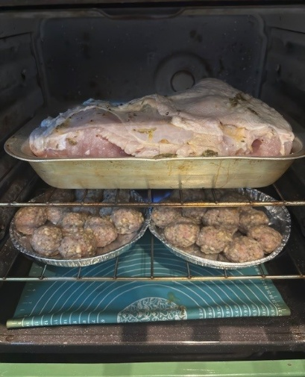
Vegetables.
It’s easy to buy enough vegetables at Christmas for a siege but they need to be kept in good condition.
- Broccoli, cauliflower, cabbage etc. Cut off any unwanted leaves and the bottom of the stalks (about 1 cm). Stand with the cut stalks in about 2 cm water in a container in the fridge.
- Celery. As above but remove just a slice from the base of the stalks.
- Potatoes, Parsnips, carrots, swedes, celeriac and other root veg, leeks, sprouts etc. Store in a large paper bag in a cool, dark place if the fridge is too full. If any start getting floppy, try cutting off a slice at the stem/root end and standing overnight, cut-side down in water, in the fridge.
- Mushrooms. Remove stalks for stock and then layer the caps between kitchen paper to absorb moisture in the fridge or somewhere cold.

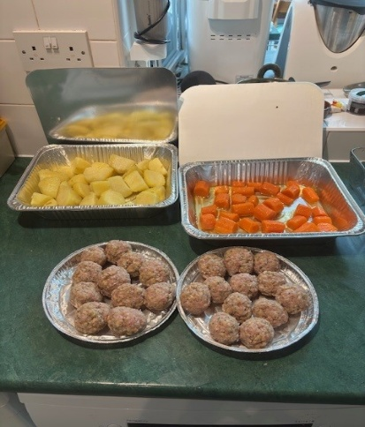
Sweet stuff.
Your Christmas pudding(s), cake and mincemeat can all be made much earlier for gentle maturing. But, if you ran out of time, here’s a quick alternative cake that is seasonally moist and spicy (there’s an audio version too).
Equipment.
- Probe thermometer. And mine talks too!
- Foil dishes. It is worth using large, deep foil dishes with card lids when preparing roast vegetables for the masses. You can prepare ahead, use them for storage, cook in them and save on the washing-up. Take care if they are heavy and contain hot fat. Placing them in the oven on a metal tray is safer.
- Lidded plastic boxes. 2 and 4 litre ice-cream boxes plus smaller, stacking boxes saves fridge and freezer space.
- Oven/freezer/microwave-proof glass dishes (ideally with lids). Cook-ahead red cabbage, root mash and more can be frozen, re-heated in the microwave.
- Stockpot/steamer. If possible, a deep stock/pasta pan with a perforated liner and at least one steamer “basket” is useful for vegetables and the pudding.,
- Microwave. Reheating the root mash, red cabbage and even the gravy on medium power saves more pots and pans.
- Warming tray/oven. Keeping everything hot while the meal comes together, on warmed plates, is worth the effort.

Make well ahead and freeze.

Herb butter.
100g butter.
1 tablespoon rosemary, thyme, parsley and/or other herb leaves, finely chopped.
1 lemon, zest and juice.
Salt and pepper.

Mix together. Store in lidded container in freezer or fridge.

Root mash.
1 swede peeled and chopped.
1 celeriac and/or large, sweet potato, ditto.
4-5 carrots, ditto.
Butter, salt and pepper.

Place all the prepared vegetables in a pan, cover with water and simmer until tender.
Drain and mash the vegetables with butter, salt and pepper to taste.
Store in lidded containers in freezer or fridge.

My Tips.
Roughly, aim for equal weights of each vegetable, cut into equal sizes.

Braised red cabbage.
1 red cabbage (about 750g), outer leaves and core removed, remainder thinly sliced and chopped.
370g onions, peeled and chopped small.
350g cooking apples, cored and chopped small.
3 handfuls raisins.
3 tablespoons soft brown sugar
3 tablespoons cider or wine vinegar
1 orange, zest and juice.
1 cinnamon stick.
4 whole cloves.
1 star anise.
1 teaspoon ground mixed spice.
1 quarter nutmeg, grated.
1 teaspoon garlic powder (or 1 fresh clove, finely chopped)
1 flat teaspoon salt.
1 flat teaspoon ground black pepper.

Place all the ingredients in a large lidded ovenproof pan and mix thoroughly.
Place in preheated oven 150C, Gas 2 for 2 hours.
Store in lidded containers in freezer or fridge.

D minus 2.

Turkey stock.
1 Onion peeled and roughly chopped.
2 carrots, ditto.
2 sticks celery, ditto.
Turkey pieces (2 wing tips, parson’s nose, any bones, giblets).
A generous slug of olive oil.
3 bay leaves (plus any other fresh herbs handy).

Place the vegetables and turkey bits in a roasting tin. Drizzle with oil and mix thoroughly to lightly coat.
Roast in the oven at 160C, Gas 4 for about 30 minutes.
Place in stock pot with the herbs and cover with water.
Bring to a very gentle simmer for several (5-6) hours, checking that the pan doesn’t boil dry.
Lift the liner containing the turkey bits and vegetables from the pan to leave the stock. Continue simmering if needed to concentrate the flavour.
Store in lidded containers in freezer or fridge.

Gravy.
Half onion, peeled or bunch spring onions, trimmed and chopped fine.
Half stick celery peeled and chopped fine.
1 carrot, ditto.
Trimmed stalks only of 500g mushrooms, chopped fine.
Knob of butter.
About half litre stock.
1 glass wine or cider.
1 chicken stockpot/cube.
Seasoning to taste.

Gently sauté the vegetables in the butter before adding the remaining ingredients and simmering gently for about 30 minutes.
Using a hand-blender, whizz the vegetables to thicken the gravy.
Continue to simmer to thicken further and adjust seasoning as needed.
Store in lidded containers in freezer or fridge.

Baked fruit salad.

1 pineapple, cored, flesh chopped and skin scraped clean.
2 firm pears cored and chopped.
2 eating apples cored and chopped.
2 bananas skinned and chopped.
Large tin or bottle of apricots, peaches or similar.
2 oranges, zest and juice.
1 handful dried figs, stalks removed and chopped.
1 handful dried dates, chopped.
1 handful crystallised ginger, chopped.
1 handful dried apricots, chopped.
1 handful raisins.
2 star anise.
1 stick cinnamon.
Fruit juice (apple, orange etc) to cover.

Place all the fruit and spices and juice in a slow cooker on Low and cook for 6 hours.
Store in lidded containers in fridge.
Reheat in the oven or microwave to serve or eat cold.

My Tips. This fruit salad is a good addition or alternative to the Christmas pudding. Any suitable firm fruit can be used.
Using a large lidded ovenproof dish, it could be cooked alongside the braised red cabbage but will need a couple more hours.

Final Countdown.

D minus 1 Christmas Eve | D Day - Christmas Day
Defrost herb butter, root mash, red cabbage and stock/gravy as needed.  Brine turkey.  60g salt dissolved in about 2 tablespoons boiling water.  1 litre cold water.  1 lobe (half) turkey breast.  Place salt solution and cold water in a lidded plastic box. Submerge turkey in the liquid, lid and store in the fridge for 24 hours.  My Tips: Repeat in a second box if cooking both halves of the breast.  If using a chicken, remove any rubber bands or other ties before brining.  Stuffing balls.  200g dried stuffing mix.  700g sausage meat.  1 lemon, zest and juice.  Fresh herbs such as thyme, sage etc leaves only, chopped fine.  Add enough boiling water to the dry mix to create a firm stuffing and allow to cool.  Mix in with the sausage meat and other ingredients to form into balls (about 5cm diameter).  Place in a foil tray, cover with foil, store in fridge. | Turkey and stuffing balls.  About 0900. Set oven to100C, Gas S.  Drain lobe of turkey breast from brine.  Push herb butter under skin.  Place in roasting tray, skin side up and place on top shelf in oven.  Place uncovered stuffing balls on lower shelf.  About 1200. Test if the centre of the meat (not touching a bone) has reached 70C. If not, continue to cook.  Once up to temperature, remove turkey in tray from oven, pour off any liquid for the gravy/stock, cover with foil and a kitchen towel and keep warm while resting for at least 45 minutes. Also remove stuffing balls, cover with foil and keep warm.  About 1300. If desired, turn oven to maximum heat and, removing foil and towel, cook turkey for 5 minutes to brown and crisp skin before slicing and serving.
Roast potatoes and parsnips.  6-8 medium potatoes, peeled.  3-4 parsnips, peeled.  Salt.  Goose or duck fat.  Olive oil.  2-3 tablespoons honey.  Salt and pepper.  Cut the vegetables to size and place the potatoes in fresh cold salted water inside the perforated liner, in the stockpot.  Put on the lid and bring to the boil and simmer for 5 minutes.  Lift the liner, draining the hot water from the potatoes back into the pan.  Tip the potatoes into a deep foil dish and spoon over the goose fat.  Place the cut parsnips into the liner and return to the boiling water to simmer for 5 minutes.  Drain the parsnips and tip into a separate foil dish with a few tablespoons of olive oil.  Turn the potatoes in the goose fat until well covered and in a single layer.  Repeat with the parsnips and olive oil.  When cool, cover dishes with card lids and store in fridge. | About 1200.  While the turkey is resting, turn up the oven to200C, Gas 6 and uncover the trays, turn the vegetables to recoat with fat or oil, season lightly with salt and pepper and drizzle the honey over the parsnips.  Place the trays in the oven: potatoes on top shelf, parsnips below.  Cook for 30 minutes then turn over in trays.  Continue cooking for 15-30 minutes until crisp enough. Reduce oven temperature to very low to keep everything warm.
Vegetables.  Selection of sprouts, cauliflower, etc.  Prepare, trim and cover with salted water, store in fridge. | About 1215. In large stock pot, place Christmas pudding in liner or on silicone mat, add water to halfway up pudding and turn on heat to simmer.  About 1230. Place harder vegetables such as sprouts and carrots to steam in one basket above the reheating Christmas pudding.  About 1240. Place remaining vegetables in second basket above the first and continue steaming.  Once cooked, keep all warm until served.
Root mash, braised red cabbage, gravy. | About 1230. Reheat each in microwave and keep warm until served.
Christmas pudding and fruit salad. | Keep the pudding warm until served.  Reheat the fruit salad in microwave or oven and keep warm.

A Christmas Turkey
On the first day of Christmas my true love said to me I’ve brought a nice fresh turkey and a proper Christmas Tree.
On the second day of Christmas much laughter could be heard as we tucked into our turkey - a most delicious bird.
On the third day of Christmas came people from next door – the turkey tasted just as good as it did the day before.
On the fourth day of Christmas came relations young and old -we finished up the Christmas pud and ate the turkey cold.
On the fifth day of Christmas outside the snowflakes scurried but we were nice and warm as we had the turkey curried.
On the sixth day of Christmas the Christmas spirit died, the children fought and bickered and we had the turkey fried.
On the seventh day of Christmas my true love he did wince when he sat down to the table and we had the turkey minced.
On the eighth day of Christmas the dog had run for shelter - he’d seen our turkey pancakes and the glass of Alka Seltzer.
On the ninth day of Christmas by lunchtime dad was blotto – he knew that bird was back again and this time as Risotto.
On the tenth day of Christmas we were drinking homemade brew – as if this wasn’t bad enough we were eating turkey stew.
On the eleventh day of Christmas the Christmas tree was moulting – with chilli sauce and oyster sauce the turkey was revolting.
On the twelfth day of Christmas we had a smile upon our lips – the guest had gone - the turkey too - and we dined on Fish and chips!

Author unknown.

